# Title - All manuscripts

When is it cost effective to use transthoracic echocardiography to aid the decision to prescribe oral anticoagulants in patients with newly diagnosed atrial fibrillation? An economic evaluation

# - Names, addresses, and positions of all authors

## Corresponding Author:

Jonathan William Minton,

Research Associate

Health Economic and Decision Science

School of Health and Related Research

The University of Sheffield

Regent Court

30 Regent Street

Sheffield

S1 4DA

## Second Author:

Professor Matthew Stevenson

Professor of Health Economics

Health Economic and Decision Science

School of Health and Related Research

The University of Sheffield

Regent Court

30 Regent Street

Sheffield

S1 4DA

## Third Author:

Dr Emma Simpson,

Health Economic and Decision Science

School of Health and Related Research

The University of Sheffield

Regent Court

30 Regent Street

Sheffield

S1 4DA

## Fourth Author:

Professor Gregory Y H Lip

University of Birmingham Centre for Cardiovascular Sciences

City Hospital

Birmingham

B18 7QH

# Copyright Statement

The Corresponding Author has the right to grant on behalf of all authors and does grant on behalf of all authors, [a worldwide licence](http://www.bmj.com/sites/default/files/BMJ%20Author%20Licence%20March%202013.doc) to the Publishers and its licensees in perpetuity, in all forms, formats and media (whether known now or created in the future), to i) publish, reproduce, distribute, display and store the Contribution, ii) translate the Contribution into other languages, create adaptations, reprints, include within collections and create summaries, extracts and/or, abstracts of the Contribution, iii) create any other derivative work(s) based on the Contribution, iv) to exploit all subsidiary rights in the Contribution, v) the inclusion of electronic links from the Contribution to third party material where-ever it may be located; and, vi) licence any third party to do any or all of the above.

# - Competing interest statement - All manuscripts

# - All authors have completed the Unified Competing Interest form atwww.icmje.org/coi\_disclosure.pdf (available on request from the corresponding author) and declare: no support from any organisation for the submitted work [or describe if any]; no financial relationships with any organisations that might have an interest in the submitted work in the previous three years [or describe if any], no other relationships or activities that could appear to have influenced the submitted work [or describe if any].- Please note: The corresponding author must collect Unified Competing Interest forms from all authors and summarise their declarations as above within the manuscript. You do NOT need to send copies of the forms to the BMJ. Please click here for [further guidance](http://resources.bmj.com/bmj/authors/editorial-policies/competing-interests/)

# - Details of contributors, and the name of the guarantor - All full papers (eg not fillers or personal views)

JM: Developed model; wrote first and subsequent drafts of manuscript;

MS: Created model; commented on all drafts of manuscript;

ES: Involved in discussion on data sources and commented on manuscript drafts;

GL: Contributed to all versions of manuscript and provided clinical input.

# - Details of ethical approval (or a statement that it was not required) - All research studies

Not required

# - Details of funding - All research studies

This paper was based on research funded as part of the National Institute for Health Research Health Technology Assessment Programme (Project code 08/45/01)

# - Details of the role of the study sponsors - All research studies

The study sponsor had no role in the content of this manuscript.

# - Statement of independence of researchers from funders - All research studies  The authors are all independent of the funders.

# - Data sharing statement All research studies

# Abstract

**Background:** Atrial fibrillation (AF) is common and increases stroke risk. Echocardiography is often performed as part of the cardiological evaluation of patients with AF to assist with stroke risk stratification (and hence, decisions on thromboprophylaxis with oral anticoagulants (OACs)). The cost effectiveness of such an approach is unknown.

**Objective:** To estimate the cost-effectiveness of using transthoracic echocardiography (TTE) in helping to make the decision whether to prescribe an OAC in newly diagnosed AF patients.

**Design**: Diagnostic economic modelling analysis.

**Setting:** England & Wales

**Model:** Diagnostic discrete event simulation model.

**Comparisons:** Decisions and consequences following from using TTE in combination with the CHADS2 score (used for stroke risk stratification), compared with those when using CHADS2 alone.

**Treatments considered:** Warfarin, dabigatran and rivaroxaban were all considered separately as OACs which may be prescribed as a result of the information provided by TTE.

**Population:**  Newly diagnosed AF patients.

**Main outcome measures**: Quality adjusted life years gained, strokes averted, effects on cost and major bleeding events.

**Results:** For patients aged 50 years, using TTE does not appear clinically effective due to the problems of additional overtreatment. For patients aged 65 years, using TTE is more effective but more expensive, with incremental cost-effectiveness ratios which are below conventional willingness to pay thresholds when a newer OAC (rivaroxaban, dabigatran) is being considered, but not warfarin.

**Conclusions:** Using TTE to inform the decision whether to prescribe a newer OAC to newly diagnosed AF patients may be a clinically and cost-effective strategy.

# Introduction

## Background

Atrial fibrillation (AF) is a common arrhythmia affecting around 1-2% of the UK population and is a significant risk factor for stroke.[1] Managing AF effectively is therefore important for reducing mortality and morbidity risks that result from this condition. Oral anticoagulants (OACs) reduce the risk of stroke for AF patients, but can cause major bleeding. [2]

OACs also impose a cost burden, either directly due to drug acquisition costs in the case of newer OACs like dabigatran or rivaroxaban, or indirectly due to monitoring costs in the case of warfarin. In AF patients with an already low stroke risk, prescribing an OAC may not be clinically beneficial, as the average harm caused by additional major bleeding events can exceed the harm averted by preventing strokes. Because of this a range of risk prediction rules are used to identify the higher-risk patients who are likely to benefit from OACs.

A commonly used stroke risk prediction rule for assessing stroke risk is the CHADS2 score, which is an acronym for: (C) congestive heart failure; (H) hypertension; (A) aged 75 years or older; (D) diabetes; prior stroke or transient ischemic attack (S2) [3] The European Society of Cardiology 2010 guidelines for the management of atrial fibrillation, and subsequent 2012 focused update of these guidelines, emphasise identification of ‘truly low risk’ patients who do not need any form of antithrombotic therapy, and that even in low risk patients OACs should be considered in preference to aspirin monotherapy or aspirin-clopidogrel combination therapy. [3,4] This paper interprets this guidance as suggesting that patients should normally receive an OAC if their CHADS2 score is not zero.

## Transthoracic Echocardiography and the decision problem

This study considers whether additional diagnostic testing of newly diagnosed AF patients with CHADS2 scores of zero could be a clinically and cost-effective strategy for appropriately managing their condition. The additional screening is with transthoracic echocardiography (TTE). A CHADS2 score of zero means these patients would conventionally not be prescribed an OAC. However, TTE is able to identify abnormalities of cardiac function and structure (ABN) which indicate that, despite the low CHADS2 score, the patient has a high risk of stroke. [5,6] For these ‘hidden’ high-risk patients, prescribing an OAC is likely to be more beneficial than harmful, and so using TTE in this way improves their AF management. However, as no diagnostic is perfectly accurate, the use of TTE will produce some false positives, resulting in more patients with low stroke risk being prescribed OACs. Additionally, not all patients who are at higher stroke would be identified (false negatives), and so would remain untreated with OACs. For these reasons, not using TTE (the No TTE Strategy) could lead to better clinical outcomes for these AF patients than using TTE (the TTE Strategy).

If the TTE Strategy is clinically superior, however, it is then important to estimate whether it is also cost effective, meaning that the ratio of additional costs to additional clinical benefits of the TTE Strategy compared with No TTE strategy represents a good use of scarce resources. The National Institute for Health and Care Excellence (NICE) recommends that health benefits be defined in terms of quality-adjusted life years (QALYs), and conventionally applies thresholds ranging from £20,000 per QALY to £30,000 per QALY when deciding whether to recommend a health technology. [7] This modelling study uses this measure of health benefit and these thresholds.

# Methods

The mathematical model developed estimated the consequences of using TTE to inform the decision whether to prescribe an OAC in a range of patient populations. Four distinct cohorts were modelled, and separate scenarios were performed for each of three potential OACs: warfarin; dabigatran; and rivaroxaban. [8] A UK perspective is adopted, with costs incurred by the patient or wider society not considered. Costs were inflation-adjusted to 2012 UK values where necessary. Standard NICE discount rates for utilities and costs of 3.5% per annum are used. [9] A lifetime horizon is adopted, and in order to incorporate the effect of uncertainty on predicted outcomes, in order that the full consequences of mortality due to stroke or major bleeding events are compared. A probabilistic model is used, meaning that where possible model parameter estimates are drawn from distributions rather than assumed to be fixed values.

## Scenarios included

The recommended populations for treating with warfarin, rivaroxaban, and dabigatran are different in their clinical characteristics. Warfarin is recommended in patients with a CHADS2 score of one or more; similarly the recent NICE recommendations for rivaroxaban are equivalent to stating that patients with a CHADS2 score of one or more should receive it; and recent NICE recommendations for dabigatran are equivalent to stating that patients with a CHADS2 score of one or more should receive it if they are also aged 65 years or more. [10,11] Although full incremental analyses of the mean estimates are presented in appendix G, the purpose of this paper is not to identify the most appropriate OAC, which is a matter of clinician judgement, but to see if the use of TTE is clinically effective and cost-effective given the OAC under consideration. The scenarios in which a TTE may affect the OAC decision are described in Table 1 .

[Table 1 about here]

## Model Overview

An overview of the model is presented in Figure 1. The model comprises a short-term diagnostic stage and a long-term patient outcome stage. In the short-term stage the clinical characteristics of a hypothetical patient are generated, including the presence of an ABN. Whether or not an ABN was identified and hence an OAC was prescribed is additionally determined. In the long-term simulation the patient’s clinical outcomes are simulated. Over the patient lifetime the patient may experience a stroke or major bleeding event, both of which could cause death; patients may also die from another cause. Each of these events has associated cost and utility implications. By simulating the outcomes for a large number of hypothetical patients, the mean costs and mean QALYs for both the TTE Strategy and the No TTE strategy can be calculated. From these the incremental cost effectiveness ratio (ICER) of including TTE in the diagnostic package can be calculated.

[Figure 1 about here]

In the No TTE Strategy, none of the patients with ABN would be treated with the OAC. In the comparator strategy, a percentage of these patients with ABN would receive the OAC due to TTE correctly identifying ABN, dependent on sensitivity of TTE. However, when specificity is less than perfect a proportion of patients without ABN would also receive treatment.

In the short-term diagnostic stage of the model the population are divided into true positives (TP), true negatives (TN), false positives (FP) and false negatives (FN). The relative size of each of the four groups is a function of the proportion of the population with ABN, referred to here as the true proportion high risk (TPHR), and the sensitivity and specificity of the diagnostic technology. These are defined as follows:

* Proportion of TPs = TPHR x sensitivity;
* Proportion of TNs = (1 –TPHR) x specificity;
* Proportion of FPs = (1 – TPHR) x (1 – specificity);
* Proportion of FNs = TPHR x (1 – sensitivity).

Within the context of the model, the No TTE strategy has a sensitivity of zero and a specificity of one, meaning for this strategy the population mix comprises TPHR false negatives and (1 - TPHR) true negatives.

## Modelling long-term events

Prescribing an OAC reduces the risk of stroke, but increases risk of a potentially fatal major bleeding event. Three mutually exclusive outcomes could result from a stroke: death; a dependent state; and an independent state. Each outcome have different probabilities of occurrence, health related quality of life (HRQoL), and costs. Similarly, three mutually exclusive outcomes could result from a major bleeding event: death; an intracranial (IC) bleeding event; or a non-intracranial (NIC) bleeding event (assumed to be a gastrointestinal bleed). The severity of an IC bleed can vary substantially, and this variation of outcomes was itself simulated using data based on outcomes categorized by Glasgow Outcome Scale (GOS) score following traumatic brain injury. The full methodology used to produce these estimates is presented elsewhere. [12]

The model is dynamic and updated when events occur that affect an individual’s stroke or major bleed risk. Examples of such events are: experiencing a stroke; withdrawal of an OAC following a major bleed; and reaching 75 years of age, which increases the CHADS2 score by one point and means the patient will now receive an OAC It was assumed that if a patient experiences a stroke and is not already taking an OAC, they are prescribed OACs, provided they have not experienced a previous bleeding episode. If a patient suffers a severe intracranial haemorrhage (GOS category 2) as a result of taking OACs, their life expectancy was reduced to a maximum of 3.6 years with no QALY gain. [13] Other degrees of disablement following an ICH (GOS 3, GOS 4 and GOS 5) could also occur, which were assumed to affect quality of life but not longevity. Further details are provided in appendix A. Additionally, the risk of a major bleeding event when taking dabigatran (150mg twice daily) was also assumed to change at the age of 75, as indicated by recent evidence comparing dabigatran with warfarin. [14]

## Data sources used in model

A full list of the information used to populate the parameters in the model, including event risks, costs and utilities, is presented in Table 5 in the appendix.

## Estimating cost effectiveness

The adoption decision, defined as the strategy that is deemed most cost effective, is calculated from the mean values of the costs and the QALYs of each strategy. Scatterplots of estimates produced by the probabilistic sensitivity analysis (PSA) provide an indication of uncertainty surrounding the adoption decision. A point in the north-west quadrant indicates that the TTE Strategy is both more costly and less effective than the No TTE Strategy, and so ruled out by dominance. A point in the north-east quadrant indicates that the TTE Strategy is both more expensive and more clinically effective than the No TTE Strategy, and consideration is given to whether the ICER, the ratio of additional cost to additional benefit, is below a willingness-to-pay (WTP) threshold. Scatterplots where the scatter covers more than one quadrant indicate some level of decision uncertainty, as different quadrants suggest different decisions. [15]

## Deterministic sensitivity analyses

The cohoice of OAC represents one type of deterministic sensitivity analysis (DSA). Two additional types of DSA were also performed. Firstly, sensitivity analyses were undertaken on the joint uncertainty in the sensitivity and specificity of TTE in detecting ABN. Secondly, the effect of assuming different levels of TPHR was explored. The results for the joint uncertainty in sensitivity and specificity for three scenarios are presented in the main article, and the rest are exploredin appendix B.. The sensitivity of the results to TPHR is shown in appendix H.

# Results

Table 2 presents some summary statistics of simulated patient outcomes for the TTE Strategy and the No TTE Strategy, where the patient population is of 65 year old females with an initial CHADS2 score of 0, and the OAC is assumed to be warfarin, rivaroxaban, or dabigatran. Figure 2 show the PSA scatterplots where the OAC is either warfarin (a), rivaroxaban (b), or dabigatran (c). Table 2 also shows the mean costs and mean QALYs of the No TTE Strategy and the TTE Strategy, and the ICER comparing these strategies. Results for other patient groups are included in the appendix.

[Table 2 about here]

[Figure 2 about here

Table 2 indicates that, irrespective of the OAC, using TTE in this way reduces the proportion of deaths caused by stroke, but increases the proportion of deaths caused by major bleed. On average, the scenarios not using TTE are estimated to result in a lower rate of dependent and independent strokes, and a higher rate of major bleeding events, including intracranial haemorrhages (ICHs). For all OAC scenarios, the number of life years is estimated to be slightly greater when a strategy incorporating TTE is used compared with the strategy without TTE, but these differences are relatively small (approximately 0.1 life years).

Figure 2 and Table 2 both suggest that the cost-effectiveness of the TTE strategy compared with the no TTE strategy depends on the OAC which would be prescribed. Where the OAC is warfarin (Table 3a), the ICER comparing the two strategies is almost £40 000 per QALY; where the OAC is rivaroxaban (Table 2b), the ICER reduces to around £23 000 per QALY, and where the OAC is dabigatran (Table 2c), the ICER reduces further to around £12 000 per QALY.

## Deterministic sensitivity analyses

Table 3 shows how the estimated mean ICER depends on the sensitivity and specificity of the technology, assuming all other values are held at their mean levels, where the OAC is either a) warfarin, b) rivaroxaban, or c) dabigatran. If TTE had perfect sensitivity and specificity, then the additional cost per QALY is estimated to range from around £1,800/QALY for warfarin (a) to £1,100/QALY for dabigatran (c) [6]. However, due to the less than perfect specificity of TTE, estimated to be around 0.35, and the increased number of false positives predicted to be treated as a result of this, the ICERs increase to around £27,000-£59,000/QALY for warfarin (a), £18,000-£29,000 for rivaroxaban (b), and £10,000-£14,000 for dabigatran (c). As the ICER is a ratio, and the absolute differences in QALYs between strategies with and without TTE are small, the ICERs are shown to be highly sensitive to the values of sensitivity and specificity assumed for some scenarios.

## Overview of results for other scenarios

The full results for the 10 scenarios considered are presented in the online appendix. A brief summary, indicating whether the results suggest TTE appears cost-effective at WTP thresholds of £20,000 /QALY or £30,000/QALY, is shown in Table 4. These results suggest that the addition of TTE to help make the decision whether to prescribe an OAC is more expensive and less effective than not using TTE in patients aged 50 years. In patients aged 65 years, the strategy using TTE appears cost-effective and conventional WTP thresholds of between £20,000 and £30,000/QALY for dabigatran, and possibly for rivaroxaban. The cost-effectiveness of the strategy appears slightly more favourable for female than for male patients, but the choice of OAC and patient age appear to have much greater influence.

# Discussion

In this study, we have shown that using TTE to inform the decision whether to prescribe a newer OAC to newly diagnosed AF patients may be a clinically and cost- effective strategy. Prior to producing this model, a systematic literature review was conducted to identify, summarise and appraise existing economic studies for evaluating the cost-effectiveness of TTE in patients with AF and we identified no economic evaluations of the use of TTE in AF patients. Thus we believe this is the first such economic evaluation.

Although the aim of this assessment was to compare strategies involving TTE with strategies not involving TTE, doing this has also involved modeling the effects of prescribing any one of three OACs, either initially (as a result of a positive TTE result), or at a later stage due to either experiencing a stroke or reaching the age of 75 years. Appendix G presents full incremental analyses for each of the four patient groups based on the mean estimates from the PSA samples. However, the evidence used to inform the relevant model parameters were not obtained systematically, and the model was not developed so as to be able to estimate the effect of more complex scenarios which may be of clinical relevance, as discussed in the implications for research section. Because of these limitations, the full incremental results should be considered exploratory and indicative rather than robust and authoritative.

An additional limitation was in using only the the CHADS2 clinical risk prediction tool. An alternative to this tool is the CHA2DS2-VASc score, which is considered to be better at distinguishing low risk from very low risk patients, and is the only such tool recommended in the 2012 focused update of the ESC guidelines. [3,4,16,17] CHA2DS2-VASc was not used in these analyses as the recent NICE recommendations for the use of dabigatran and rivaroxaban both map onto specific CHADS2 risk scores, but not specific CHA2DS2-VASc risk scores. [10,11]

Apart from age and stroke history, the clinical characteristics of patients which are used in CHADS2 were not independently modeled, and so were assumed not to develop over a patient’s lifetime. As many patients with an initial CHADS2 score of zero may become diabetic before reaching the age of 75 years or suffering a stroke, this means the model is likely to slightly over-estimate the time that someone who has not been identified with LA ABN will not receive an OAC.

The dose of dabigatran was fixed at 150mg twice daily, rather than allowing some patients to receive a lower dose of 110mg twice daily. The stroke risk associated with patients with LA ABN was assumed not to change as a patient ages; ideally differential rates by age or by the number (and type) of abnormalities would be used but these data were not identified.

Within the study used to derive the sensitivity and specificity of TTE, transoesophageal echocardiography (TOE), was assumed to be a perfect gold standard, and so our model also made this assumption. [6] Using TOE as the gold standard, TTE was estimated to have a very high sensitivity but a specificity of only around 35 %. Within this model, this low specificity results in a considerable number of people effectively experiencing comparable risks of bleed without the increased benefits in terms of stroke risk reduction that is estimated in patients with a higher risk of stroke. If TTE were found to be superior to TOE at identifying certain types of ABN which expose patients to increased stroke risks, then the true benefits of TTE in improving patient management would be underestimated. The study used to derive sensitivity and specificity was relatively small, of fewer than 400 patients, and also formed the basis of our estimates of the TPHR. [6] This has made the assessment of the benefits of TTE uncertain. A further limitation is that the risk of death unrelated to bleeding or stroke events was taken from lifetables and were not adjusted for the probability of bleeding or stroke mortality. [18]

A key uncertainty is whether there are incidental benefits that are accrued from a TTE other than identifying some forms of ABN. If these exist, and produce even small net QALY gains (> 0.0033) then TTE would be cost effective in all scenarios, assuming a cost of £66 per test. [19] As Table 3b indicates, the structural sensitivity analyses for this scenario indicate that even a diagnostic strategy with a joint sensitivity of one and specificity of zero (i.e. prescribing everyone with the OAC) may be cost effective compared with treating no-one. The implications of this result require further research.

## Implications for Research

A range of limitations in the model and process used to identify parameters for it have been described. The imlitations of these limitations can be understoon only through further researche which address such limitations. For some scenarios the cost effectiveness estimates generated by the model depend heavily on sensitivity and specificity estimates, as well as the true proportion of genuinely high risk (ABN that can be detected by TTE) patients in this sub-population of apparently ‘low risk’ patients. The model depends strongly on data reported in a single, relatively small study conducted outside of the UK, and so may misrepresent the true values of these parameters. Having a more robust source of evidence for these parameters, with direct relevance to England and Wales, is likely to significantly improve the accuracy of the mathematical models.

The model could be developed in order to robustly compare the cost effectiveness of a broad range of clinical strategies. For example, it could be adapted so that the effect of different doses of dabigatran or different warfarin strategies could be estimated. The effect of, for example, switching from one OAC to another in response to clinical events could also be explored. As it is an individual level model, it could be adapted to model variation in bleed risk using the HAS-BLED instrument[20], and to model each CHADS­2 risk factor independently over time, including the risk of developing diabetes and the effect of this condition on HRQoL and healthcare provider cost. Budget impact analysis could also be performed using this model to estimate, for example, how rising levels of type 2 diabetes (the D in CHADS­2) may change the size of the population affected by the use of TTE in the ways indicated.

Additional research that would improve the validity of the model include identifying any incidental net benefits to the management of newly diagnosed AF patient that could result from routine screening with TTE following initial diagnosis.

## Implications for clinical practice

If TTE were to be recommended for those patients with CHADS2 scores of zero points, there will be an increase in the number of TTEs performed. This is unlikely to place a great burden on the majority of hospitals who are likely to have staff trained in the use of TTE machines. It is likely that additional bed days are made available due to the reduction in stroke following appropriate management, although there is likely to be an increase in bleed related admissions.

## Conclusion

This paper presented the results of mathematical models which simulated the effects of using TTE to help make the decision whether to prescribe an OAC in a range of patients with AF. It was estimated that when rivaroxaban or dabigatran is the OAC of choice then it appears cost-effective to use TTE in patients aged 65 years; when warfarin is the OAC of choice, then the addition of TTE does not appear cost-effective at standard WTP thresholds of either £20,000 per QALY or £30,000/QALY. We suggest that if considering prescribing a newer OAC, it may be both clinically effective and cost effective to use TTE to help inform the decision in more elderly patients.

# References

1 Go AS, Hylek EM, Phillips KA, *et al.* Prevalence of diagnosed atrial fibrillation in adults: national implications for rhythm management and stroke prevention: the AnTicoagulation and Risk Factors in Atrial Fibrillation (ATRIA) Study. *JAMA : the journal of the American Medical Association* 2001;**285**:2370–5.

2 Rivaroxaban-once daily, oral, direct factor Xa inhibition compared with vitamin K antagonism for prevention of stroke and Embolism Trial in Atrial Fibrillation: rationale and design of the ROCKET AF study. *American heart journal* 2010;**159**:340–347.e1.

3 Camm AJ, Kirchhof P, Lip GY, *et al.* Guidelines for the management of atrial fibrillation: the Task Force for the Management of Atrial Fibrillation of the European Society of Cardiology (ESC). *Eur Heart J* 2010;**31**:2369–429.

4 Camm AJ, Lip GYH, De Caterina R, *et al.* 2012 focused update of the ESC Guidelines for the management of atrial fibrillation: An update of the 2010 ESC Guidelines for the management of atrial fibrillation \* Developed with the special contribution of the European Heart Rhythm Association. *European heart journal* Published Online First: 24 August 2012. doi:10.1093/eurheartj/ehs253

5 Transesophageal echocardiographic correlates of thromboembolism in high-risk patients with nonvalvular atrial fibrillation. The Stroke Prevention in Atrial Fibrillation Investigators Committee on Echocardiography. *Ann Intern Med* 1998;**128**:639–47.

6 Providencia R, Botelho A, Trigo J, *et al.* Possible refinement of clinical thromboembolism assessment in patients with atrial fibrillation using echocardiographic parameters. *Europace* 2012;**14**:36–45.

7 NICE. Guide to the methods of technology appraisal. 2008.http://www.nice.org.uk/media/B52/A7/TAMethodsGuideUpdatedJune2008.pdf

8 Pliskin JS, Shepard DS, Weinstein MC. Utility Functions for Life Years and Health Status. *Operations Research* 1980;**28**:206–24.

9 NICE. Guide to the methods of technology appraisal. NICE methods guide. 2008;:80.

10 NICE. Rivaroxaban for the prevention of stroke and systemic embolism in people with atrial fibrillation. NICE technology appraisal guidance 256. 2012.http://www.nice.org.uk/nicemedia/live/13746/59295/59295.pdf (accessed 28 Sep2012).

11 NICE. Dabigatran etexilate for the prevention of stroke and systemic embolism in atrial fibrillation. NICE technology appraisal guidance 249. 2012.http://www.nice.org.uk/nicemedia/live/13677/58470/58470.pdf (accessed 28 Sep2012).

12 Simpson EL, Stevenson MD, Scope A, *et al.* Echocardiography in newly diagnosed atrial fibrillation patients: a systematic review and economic evaluation. 2012.

13 PVS TM-STF on. Medical aspects of the persistent vegetative state: second of two parts. *The New England Journal of Medicine* 1994;**330**.http://www.nejm.org/doi/full/10.1056/NEJM199406023302206

14 Eikelboom JW, Wallentin L, Connolly SJ, *et al.* Risk of bleeding with 2 doses of dabigatran compared with warfarin in older and younger patients with atrial fibrillation: an analysis of the randomized evaluation of long-term anticoagulant therapy (RE-LY) trial. *Circulation* 2011;**123**:2363–72.

15 Drummond MF, Schulpher MJ, Torrance GW, *et al.* *Methods for the Economic Evaluation of Health Care Programmes*. Third Edit. Oxford: : OUP 2005.

16 Lip GY, Nieuwlaat R, Pisters R, *et al.* Refining clinical risk stratification for predicting stroke and thromboembolism in atrial fibrillation using a novel risk factor-based approach: the euro heart survey on atrial fibrillation. *Chest* 2010;**137**:263–72.

17 Olesen JB, Lip GYH, Hansen ML, *et al.* Validation of risk stratification schemes for predicting stroke and thromboembolism in patients with atrial fibrillation: nationwide cohort study. *BMJ* 2011;**342**:d124–d124.

18 ONS. Interim Life Tables. 2011;**2012**.http://www.ons.gov.uk/ons/taxonomy/index.html?nscl=Interim+Life+Tables

19 DoH. NHS Reference Costs 2009-2010. 2011;**2012**.http://www.dh.gov.uk/en/Publicationsandstatistics/Publications/PublicationsPolicyAndGuidance/DH\_123459

20 Lip GYH, Frison L, Halperin JL, *et al.* Comparative validation of a novel risk score for predicting bleeding risk in anticoagulated patients with atrial fibrillation: the HAS-BLED (Hypertension, Abnormal Renal/Liver Function, Stroke, Bleeding History or Predisposition, Labile INR, Elderly, Drug. *Journal of the American College of Cardiology* 2011;**57**:173–80.

21 Friberg L, Rosenqvist M, Lip GYH. Evaluation of risk stratification schemes for ischaemic stroke and bleeding in 182 678 patients with atrial fibrillation: the Swedish Atrial Fibrillation cohort study. *European heart journal* Published Online First: 13 January 2012. doi:10.1093/eurheartj/ehr488

22 Lip GYH, Edwards SJ. Stroke prevention with aspirin, warfarin and ximelagatran in patients with non-valvular atrial fibrillation: a systematic review and meta-analysis. *Thrombosis research* 2006;**118**:321–33.

23 Patel MR, Mahaffey KW, Garg J, *et al.* Rivaroxaban versus Warfarin in Nonvalvular Atrial Fibrillation. *New England Journal of Medicine* 2011;**365**:883–91.

24 Rivero-Arias O, Ouellet M, Gray A, *et al.* Mapping the Modified Rankin Scale (mRS) Measurement into the Generic EuroQol (EQ-5D) Health Outcome. *Medical Decision Making* 2010;**30**:341–54.

25 Simpson EL, Stevenson MD, Rawdin A, *et al.* Thrombophilia testing in people with venous thromboembolism: systematic review and cost-effectiveness analysis. *Health Technology Assessment* 2009;**13**. doi:10.3310/hta13020

26 Ara R, Brazier JE. Populating an economic model with health state utility values: moving toward better practice. *Value in health : the journal of the International Society for Pharmacoeconomics and Outcomes Research* 2010;**13**:509–18.

27 NICE. Dabigatran etexilate for the prevention of stroke and systemic embolism in atrial fibrillation: Final appraisal determination. 2011;**2012**.http://www.nice.org.uk/nicemedia/live/12225/56899/56899.pdf

28 Group LND. A briefing paper on Dabigatran and Rivaroxaban: What we know so far... 2012;**2012**.http://www.nelm.nhs.uk/en/NeLM-Area/Evidence/Drug-Specific-Reviews/A-briefing-paper-on-dabigatran-and-rivaroxaban/

29 BNF. Warfarin. 2011;**2012**.https://mail.google.com/mail/u/1/#inbox/134f06255f3f63de

30 Sandercock P, Berge E, Dennis M, *et al.* A systematic review of the effectiveness, cost-effectiveness and barriers to implementation of thrombolytic and neuroprotective therapy for acute ischaemic stroke in the NHS. *Health Technology Assessment* 2002;**6**.

31 NHS. National Stroke Strategy Impact Assessment. 2007;**2012**.http://www.dh.gov.uk/prod\_consum\_dh/groups/dh\_digitalassets/documents/digitalasset/dh\_081054.pdf

32 Curtis L. Unit Costs of Health and Social Care 2010. Kent: 2010.

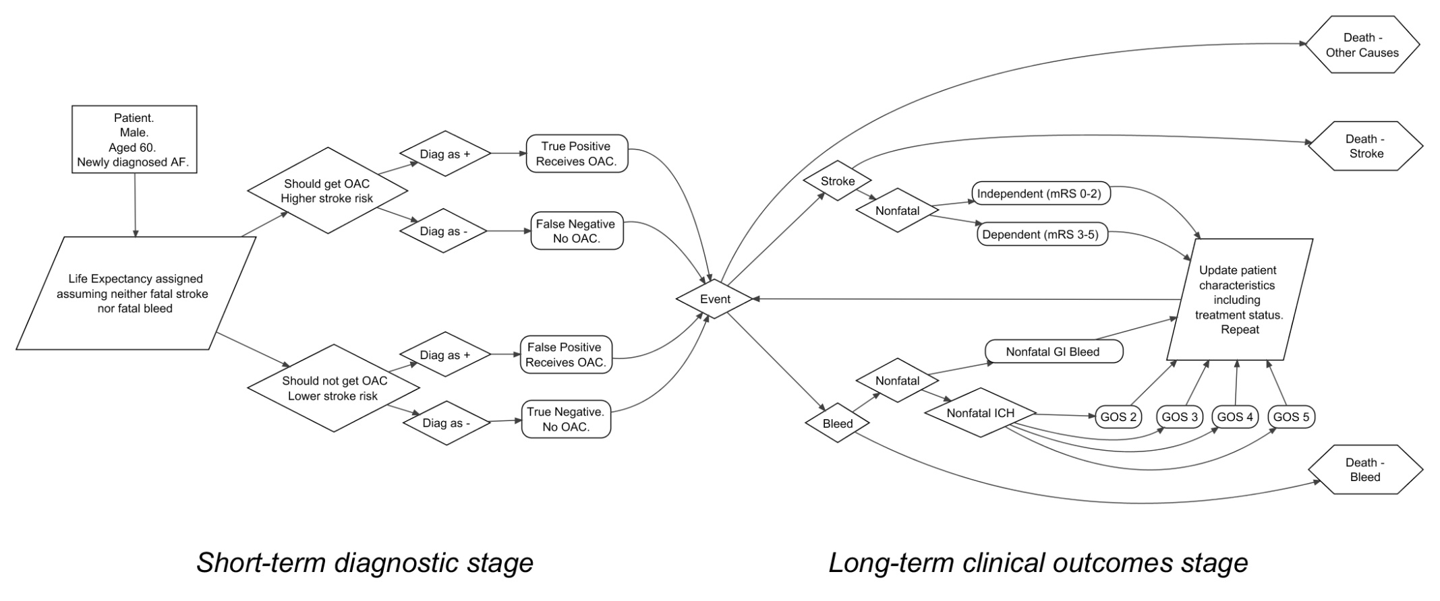

Figure 1 Graphical representation of the mathematical model

|  |  |  |  |
| --- | --- | --- | --- |
| **CHADS2 score** | **Prescribe dabigatran** | **Prescribe warfarin** | **Prescribe rivaroxaban** |
| 0 | No | No | No |
| 1 | Yes (age 65 or over) | Yes (or aspirin) | Yes |
| 2 or more | Yes | Yes | Yes |
| **Cohorts simulated** | **Scenarios considered for dabigatran** | **Scenarios considered for warfarin** | **Scenarios considered for rivaroxaban** |
| Males, age 50, CHADS2 score of zero | No † | Yes | Yes |
| Females, age 50, CHADS2 score of zero | No † | Yes | Yes |
| Males, age 65, CHADS2 score of zero | Yes | Yes | Yes |
| Females, age 65, CHADS2 score of zero | Yes | Yes | Yes |
| \* Patient would automatically receive treatment.  † OAC not permitted under NICE guidance | | | |

Table 1 Simplified OAC indications by OAC, and patient cohorts run for each OAC

|  |  |  |  |  |  |  |  |  |  |  |  |  |  |  |  |  |  |  |  |  |  |  |  |  |  |  |  |  |  |  |  |  |  |  |  |  |  |  |  |  |  |  |  |  |  |  |  |
| --- | --- | --- | --- | --- | --- | --- | --- | --- | --- | --- | --- | --- | --- | --- | --- | --- | --- | --- | --- | --- | --- | --- | --- | --- | --- | --- | --- | --- | --- | --- | --- | --- | --- | --- | --- | --- | --- | --- | --- | --- | --- | --- | --- | --- | --- | --- | --- |
| |  |  |  |  |  |  |  |  |  |  |  |  | | --- | --- | --- | --- | --- | --- | --- | --- | --- | --- | --- | --- | |  | | ***Cause of Death (%)*** | | | ***Average Number of Events*** | | | | ***Cost-effectiveness*** | | | | ***Strategy*** | **Life Years** | **Stroke** | **Bleed** | **Other** | **Dependent Strokes** | **Independent Strokes** | **ICH** | **NICH** | **Mean Cost (£)** | **Mean QALY** | **ICER** | | **Without TTE** | 17.132 | 9.0 | 0.9 | 90.2 | 0.087 | 0.192 | 0.007 | 0.052 | 1 974 | 9.94 | 39 569 | | **With TTE** | 17.204 | 8.0 | 1.3 | 90.7 | 0.078 | 0.172 | 0.010 | 0.079 | 3 106 | 9.97 | |
| 1. Warfarin |
| |  |  |  |  |  |  |  |  |  |  |  |  | | --- | --- | --- | --- | --- | --- | --- | --- | --- | --- | --- | --- | |  | | ***Cause of Death (%)*** | | | ***Average Number of Events*** | | | | ***Cost-effectiveness*** | | | | ***Strategy*** | **Life Years** | **Stroke** | **Bleed** | **Other** | **Dependent Strokes** | **Independent Strokes** | **ICH** | **NICH** | **Mean cost (£)** | **Mean QALY** | **ICER** | | **Without TTE** | 19.460 | 10.5 | 1.1 | 88.4 | 0.103 | 0.223 | 0.009 | 0.066 | 1 955 | 9.95 | 22 751 | | **With TTE** | 19.554 | 9.4 | 1.6 | 89.0 | 0.093 | 0.201 | 0.012 | 0.096 | 3 039 | 9.99 | |
| 1. Rivaroxaban |
| |  |  |  |  |  |  |  |  |  |  |  |  | | --- | --- | --- | --- | --- | --- | --- | --- | --- | --- | --- | --- | |  | | ***Cause of Death (%)*** | | | ***Average Number of Events*** | | | | ***Cost-effectiveness*** | | | | ***Strategy*** | **Life Years** | **Stroke** | **Bleed** | **Other** | **Dependent Strokes** | **Independent Strokes** | **ICH** | **NICH** | **Mean cost (£)** | **Mean QALY** | **ICER** | | **Without TTE** | 19.485 | 10.2 | 1.1 | 88.7 | 0.099 | 0.220 | 0.009 | 0.066 | 1 942 | 9.95 | 12 314 | | **With TTE** | 19.598 | 9.0 | 1.6 | 89.4 | 0.089 | 0.195 | 0.012 | 0.097 | 2 946 | 10.01 | |
| 1. dabigatran |

Table 2 Simulated outcomes for 65 year old females with newly diagnosed atrial fibrillation and an initial CHADS2 score of 0, where the decision is to prescribe either a) warfarin; b) rivaroxaban; c) dabigatran. TTE: Transthoracic echocardiography; ICER: incremental cost effectiveness ratio (In £/QALY). QALY: Quality adjusted life year

Figure 2 Probabilistic sensitivity analysis (PSA) scatterplots of using transthoracic echocardiography to inform the decision whether to prescribe either warfarin, rivaroxaban, or dabigatran to 65 year old females with atrial fibrillation and an CHADS2 score of zero.

|  |  |  |
| --- | --- | --- |
| X:\BMJ Echo AF Manuscript\S8\scatter_W_65_F.jpeg | X:\BMJ Echo AF Manuscript\S8\scatter_R_65_F.jpeg | X:\BMJ Echo AF Manuscript\S8\scatter_D_65_F.jpeg |
| 1. warfarin | 1. rivaroxaban | 1. dabigatran |

Table 3 Illustration of the effect of different levels of sensitivity and specificity on ICER of TTE compared with no TTE in cohorts of female patients aged sixty five, and with an initial CHADS2 score of zero, in making the decision whether to prescribe a) warfarin, b) rivaroxaban, or c) dabigatran. The four cells with sensitivity and specificity values closest to the empirical values are underlined. (Amounts in £1000 / QALY; >99; Over £99,000/QALY; D: Dominated; ∞: infinity)

|  |  |  |  |  |  |  |  |  |  |  |  |  |
| --- | --- | --- | --- | --- | --- | --- | --- | --- | --- | --- | --- | --- |
|  | | *Specificity* | | | | | | | | | | |
|  | | **0** | **0.1** | **0.2** | **0.3** | **0.4** | **0.5** | **0.6** | **0.7** | **0.8** | **0.9** | **1** |
| *Sensitivity* | **0** | D | D | D | D | D | D | D | D | D | D | ∞ |
| **0.1** | D | D | D | D | D | D | D | D | D | >99 | 8.1 |
| **0.2** | D | D | D | D | D | D | D | D | >99 | 24.4 | 4.6 |
| **0.3** | D | D | D | D | D | D | D | >99 | 39.9 | 12.9 | 3.4 |
| **0.4** | D | D | D | D | D | D | >99 | 54.7 | 21.0 | 9.0 | 2.8 |
| **0.5** | D | D | D | D | D | >99 | 68.9 | 28.8 | 14.4 | 7.0 | 2.5 |
| **0.6** | D | D | D | D | >99 | 82.4 | 36.5 | 19.8 | 11.1 | 5.8 | 2.3 |
| **0.7** | D | D | D | >99 | 95.4 | 44.1 | 25.1 | 15.2 | 9.1 | 5.0 | 2.1 |
| **0.8** | D | D | >99 | >99 | 51.4 | 30.3 | 19.2 | 12.4 | 7.8 | 4.5 | 2.0 |
| **0.9** | D | >99 | >99 | 58.6 | 35.4 | 23.2 | 15.7 | 10..6 | 6.9 | 4.1 | 1.9 |
| **1** | >99 | >99 | 65.7 | 40.5 | 27.1 | 18.9 | 13.3 | 9.2 | 6.1 | 3.7 | 1.8 |

|  |  |  |  |  |  |  |  |  |  |  |  |  |
| --- | --- | --- | --- | --- | --- | --- | --- | --- | --- | --- | --- | --- |
| ***b)*** | | *Specificity* | | | | | | | | | | |
|  | | **0** | **0.1** | **0.2** | **0.3** | **0.4** | **0.5** | **0.6** | **0.7** | **0.8** | **0.9** | **1** |
| *Sensitivity* | **0** | D | D | D | D | D | D | D | D | D | D | ∞ |
| **0.1** | D | D | D | D | D | D | D | D | D | 77.0 | 7.3 |
| **0.2** | D | D | D | D | D | D | D | D | 65.3 | 17.4 | 4.1 |
| **0.3** | D | D | D | D | D | D | >99 | 61.4 | 23.9 | 10.1 | 3.0 |
| **0.4** | D | D | D | D | D | >99 | 59.5 | 28.4 | 14.8 | 7.3 | 2.4 |
| **0.5** | D | D | D | D | >99 | 58.3 | 31.7 | 18.6 | 10.9 | 5.8 | 2.1 |
| **0.6** | D | D | >99 | >99 | 57.5 | 34.2 | 21.8 | 14.0 | 8.7 | 4.8 | 1.9 |
| **0.7** | D | >99 | >99 | 57.0 | 36.3 | 24.4 | 16.7 | 11.3 | 7.3 | 4.2 | 1.7 |
| **0.8** | >99 | 93.2 | 56.6 | 37.9 | 26.6 | 19.0 | 13.6 | 9.5 | 6.3 | 3.7 | 1.6 |
| **0.9** | 87.0 | 56.2 | 39.3 | 28.5 | 21.1 | 15.6 | 11.5 | 8.2 | 5.6 | 3.4 | 1.5 |
| **1** | 56.0 | 40.4 | 30.1 | 22.9 | 17.5 | 13.3 | 10.0 | 7.3 | 5.0 | 3.1 | 1.5 |

|  |  |  |  |  |  |  |  |  |  |  |  |  |
| --- | --- | --- | --- | --- | --- | --- | --- | --- | --- | --- | --- | --- |
| ***c)*** | | *Specificity* | | | | | | | | | | |
|  | | **0** | **0.1** | **0.2** | **0.3** | **0.4** | **0.5** | **0.6** | **0.7** | **0.8** | **0.9** | **1** |
| *Sensitivity* | **0** | D | D | D | D | D | D | D | D | D | D | ∞ |
| **0.1** | D | D | D | D | D | D | D | D | >99 | 28.3 | 6.2 |
| **0.2** | D | D | D | D | D | >99 | >99 | 46.8 | 23.8 | 11.2 | 3.3 |
| **0.3** | D | D | >99 | >99 | 99.6 | 57.0 | 35.4 | 22.2 | 13.4 | 7.1 | 2.4 |
| **0.4** | >99 | >99 | 97.7 | 63.5 | 43.6 | 30.6 | 21.5 | 14.7 | 9.5 | 5.3 | 1.9 |
| **0.5** | 96.6 | 67.9 | 49.8 | 37.2 | 28.0 | 21.0 | 15.5 | 11.0 | 7.4 | 4.3 | 1.6 |
| **0.6** | 54.5 | 42.5 | 33.5 | 26.4 | 20.7 | 16.1 | 12.2 | 8.9 | 6.1 | 3.6 | 1.4 |
| **0.7** | 38.1 | 31.0 | 25.3 | 20.5 | 16.5 | 13.0 | 10.1 | 7.5 | 5.2 | 3.1 | 1.3 |
| **0.8** | 29.3 | 24.5 | 20.4 | 16.8 | 13.7 | 11.0 | 8.6 | 6.4 | 4.5 | 2.8 | 1.2 |
| **0.9** | 23.9 | 20.2 | 17.1 | 14.3 | 11.8 | 9.5 | 7.5 | 5.7 | 4.0 | 2.5 | 1.1 |
| **1** | 20.1 | 17.3 | 14.7 | 12.4 | 10.3 | 8.4 | 6.7 | 5.1 | 3.6 | 2.3 | 1.1 |

Table 4 Qualitative summary of results of all 10 scenarios. ICERs presented to nearest £1,000/QALY. QALY: Quality Adjusted Lifeyear. ICER: Incremental Cost Effectiveness Ratio. NA: Not applicable. OAC: Oral anticoagulant. TTE: Transthoracic echocardiography. Simple Dominance: TTE strategy is more expensive and less effective than no TTE strategy.

|  |  |  |  |  |  |
| --- | --- | --- | --- | --- | --- |
| Age | Gender | OAC | ICER of TTE compared with no TTE strategy | TTE optimal | |
| At £20,000 / QALY | At £30,000 / QALY |
| 50 | male | warfarin | NA: Simple dominance | No | No |
| 50 | female | warfarin | NA: Simple dominance | No | No |
| 65 | male | warfarin | £67,000/QALY | No | No |
| 65 | female | warfarin | £40,000/QALY | No | No |
| 50 | male | rivaroxaban | NA: Simple dominance | No | No |
| 50 | female | rivaroxaban | NA: Simple dominance | No | No |
| 65 | male | rivaroxaban | £30,000/QALY | No | Borderline[[1]](#footnote-1) |
| 65 | female | rivaroxaban | £23,000/QALY | No | Yes |
| 65 | male | dabigatran | £15,000/QALY | Yes | Yes |
| 65 | female | dabigatran | £12,000/QALY | Yes | Yes |

# Appendices

## Appendix A: Parameters used in model

|  |  |  |  |
| --- | --- | --- | --- |
|  | **Category** | **Description** | **References** |
| **Risks/Probabilities** | Death from other causes | Nonparametric | UK Lifetables. [18] |
| Sensitivity and Specificity of TTE in detecting ABN | Jointly estimated from Dirichlet distribution  (FN, TP, TN, FP) =  (5, 87, 83, 159) | Table 2 of Providencia et al 2012 [6] |
| Proportion of patients with ABN | Beta(2.5, 22.5) for CHADS2  Beta(0.5, 11.5) for CHA2DS2-VASc  (Both with prior of 0.5 added to both cell counts.) | Table 2 of Providencia et al 2012 [6] |
| Annual stroke risk by CHADS2 score | Annual risks (95% Credible intervals) by CHADS2 were reported as follows:  0.6% (0.5% to 0.7%) for CHADS2=0  3.0% (2.9% to 3.2%) for CHADS2=1  4.2% (4.0% to 4.4%) for CHADS2=2  7.1% (6.7% to 7.5%) for CHADS2=3  11.1% (10.4% to 11.8%) for CHADS2=4 | Friberg 2012[21] |
| Annual stroke risk in those with ABN | In the initial study four out of 50 patients with identified ABN had a stroke. This was used to produce a mean stroke rate of 8.0% and bootstrapped 95% CrIs of 7.2% to 8.2% | Stroke Prevention 1988 [5] |
| Relative risk (RR) of stroke in patients receiving dabigatran. | Indirect comparison simulation approach. One thousand simulated values from a lognormal distribution representing the RR of warfarin compared with placebo were multiplied by 1000 simulated values from a lognormal distribution comparing dabigatran with warfarin, to produce 1000 estimates of the RR of dabigatran compared with placebo. Mean RRs and 95% CIs/CrIs are shown below:  Reported RR warfarin vs. placebo: 0.33 (0.24 to 0.45)  Reported RR dabigatran vs. warfarin: 0.66 (0.53 to 0.82)  Derived RR dabigatran vs. placebo: 0.22 (0.15 to 0.32) | Lip et al 2006 for RR of warfarin compared with placebo [22]  Eikelboom et al 2011 for RR of dabigatran compared with warfarin[14] |
| Annual major bleeding risk for patients receiving dabigatran | Stratified by age. Credible interval calculated using simulation approach. Annual risk reported separately for people under 75 years, and people aged 75 years or older. Credible intervals were calculated by assuming sample sizes of 3618 for people aged under 75 years and 2419 for people aged 75 years or older, then sampling repeatedly and taking the values 2.5% and 97.5% of the way along the distributions. The central estimates (95% CrIs) are as follows:  Under 75: 2.1% (1.7 to 2.6%)  75 and older: 5.1% (4.2% to 6.0%) | Eikelboom et al 2011 [14] |
| Relative risk (RR) of stroke in patients receiving warfarin | Reported RR warfarin vs. placebo: 0.33 (0.24 to 0.45) | Lip et al 2006 [22] |
| Annual major bleeding risk for patients receiving warfarin | Stratified by age. Credible interval calculated using simulation approach. Annual risk reported separately for people under 75 years, and people aged 75 years or older. Credible intervals were calculated by assuming sample sizes of 3618 for people aged under 75 years and 2419 for people aged 75 years or older, then sampling repeatedly and taking the values 2.5% and 97.5% of the way along the distributions. The central estimates (95% CrIs) are as follows:  Under 75: 3.4% (2.5 to 3.6%)  75 and older: 4.4% (3.6% to 5.2%) | Eikelboom et al 2011 [14] |
| Relative risk (RR) of stroke in patients receiving rivaroxaban | Indirect comparison simulation approach. One thousand simulated values from a lognormal distribution representing the RR of warfarin compared with placebo were multiplied by 1000 simulated values from a lognormal distribution comparing dabigatran with warfarin, to produce 1000 estimates of the RR of dabigatran compared with placebo. Mean RRs and 95% CIs/CrIs are shown below:  Reported RR warfarin vs. placebo: 0.33 (0.24 to 0.45)  Reported RR Rivaroxaban vs. warfarin: 0.88 (0.74 to 1.03)  Derived RR Rivaroxaban vs. placebo: 0.30 (0.20 to 0.41) | Lip et al 2006 for RR of warfarin compared with placebo [22]  Patel et al 2011 for RR of rivaroxaban compared with warfarin [23] |
| Annual major bleeding risk for patients receiving rivaroxaban | The annual risk of bleeding given rivaroxaban was estimated indirectly by combining estimates of the risk of bleed given warfarin compared with placebo with estimates of the risk of bleed given rivaroxiban compared with warfarin. The central estimates (95% CrIs) were estimated to be as follows:  Under 75: 3.2% (2.5% to 4.0%)  75 or older: 4.6% (3.6% to 5.7%) | Eikelboom et al 2011 [14]  Patel et al 2011 [23] |
| Outcome following stroke | Simulation & mapping based approach described in an upcoming report.  The proportion dying of a stroke (95% CrI) was estimated to be 0.25 (0.23 to 0.27); the proportion in an independent state was estimated to be 0.56 (0.52 to 0.59); and the proportion in an dependent state following a stroke was estimated to be 0.19 (0.16 to 0.23). | Method described in report using results published in Rivero-Arias et al 2010 [24] |
| Outcome following a major bleeding event | Previous estimates. | Simpson et al 2010 [25] |
| **Utilities** | Baseline utilities by age and gender | Regression based approach, described in full in the reference. HRQoL is estimated as a function of age and gender, using the equation for the general population. | Ara et al 2010 [26] |
| Utility multiplier following stroke, utility multiplier following major non-fatal intracranial bleed | Simulation & mapping based approach described in an upcoming report.  Utility multipliers (95% CrIs) were estimated to be 0.822 (0.819 to 0.824) for an independent state following a stroke, and 0.482 (0.477 to 0.487) for a dependent state following a stroke. | Method described in report results published in  Rivero-Arias et al 2010 [24]  See Table 6 for assumed mapping between Glasgow Outcome Scale (GOS) states and modified Rankin Scale (mRS) scores, and estimated utility multipliers associated with each state. |
| **Costs** | Annual cost of dabigatran | £920. A fixed cost was assumed. | NICE FAD, 2011 [27] |
| Annual cost of rivaroxaban | £767. A fixed cost was assumed. | London New Drugs Group [28] |
| Annual cost of warfarin | £252 to £259 including monitoring costs. A uniform distribution was assumed. | BNF [29] |
| Cost of TTE | £66 | NHS Reference Costs [19] |
| Cost of death due to stroke | £7,019 (95% CrI £6,975 to £7,064) | Sandercock et al 2002 [30] |
| Costs in stroke survivors | Various. Differing according to dependent and independent states. Subdivided into one-off and continuing costs. Estimates (95% CrIs) are as follows:  Dependent stroke, one-off costs: £2830 (£2708 to £2952)  Dependent stroke, continuing annual cost: £6386 (£5749 to £7023)  Independent stroke, one-off costs: £542 (£513 to £571)  Independent stroke, continuing annual cost: £3195 (£2871 to £3518) | NHS Reference Costs [19]  NHS Stroke Strategy Impact Assessment [31]  Unit Costs of Health and Social Care 2010 [32] |
| Costs of fatal bleed | Assumed identical to costs of death due to stroke | |
| Costs of nonfatal bleed | Major bleeds subdivided into gastrointestinal (GI) and intracranial (IC). GI bleeds were assumed to incur a one-off cost but no continuing costs. The one-off cost (95% CrI) was £1261 (£1212 to £1310).  For IC bleeds, the costs depended on the Glasgow Outcome Scale (GOS) level of disability that they cause, from GOS 2 (most severe) to GOS 5 (least severe).  The one-off costs (95% CrIs) used were as follows:  GOS 2: £46785 (£40895 to £53250)  GOS 3: £10096 (£8849 to £11363)  GOS 4: £27419 (£22582 to £32964)  GOS 5: £1261 (£1211 to £1309)  GOS 4 and GOS 5 states were assumed not to have ongoing costs. The ongoing annual costs (95% CrIs) of the other states were as follows:  GOS 2: £50047 (£49645 to £50343)  GOS 3: £33949 (£33843 to £33969) | NHS Reference Costs [19] |

Table 5 Parameters used in model

|  |  |  |
| --- | --- | --- |
| **GOS state** | **Assumed equivalent to** | **Utility multiplier** |
| GOS 2: vegetative state | mRS 6: dead | 0 |
| GOS 3: severely disabled | mRS 4: moderately severely disabled; and mRS 5: severely disabled | 0.226 (95% CI 0.221 to 0.231) |
| GOS 4: moderately disabled | mRS 2: slight disability  *and*  mRS 3: moderate disability | 0.642 (95% CI 0.638 to 0.645) |
| GOS 5: good recovery | mRS 0: no symptoms  *and*  mRS 1: no significant disability | 0.895 (95% CI 0.892 to 0.898) |

Table 6 Assumed relationship between GOS and mRS, and estimated utility multipliers for each GOS state

## Appendix B: Sensitivity and Specificity tables

The tables below show how the mean ICER of the TTE compared with the No TTE strategy varies for each of 121 joint configurations of TTE sensitivity and specificity. D indicates that the TTE strategy is dominated by the No TTE strategy. Numbers show the ICER to the nearest £1000 (i.e. 19.2 refers to an ICER of £19 200/QALY). The code in the top left of each table refers to the patient population and OAC strategy under evaluation. (For example, W\_65\_0\_M refers to 65 year old males with warfarin as the OAC of choice.)

|  |  |  |  |  |  |  |  |  |  |  |  |  |  |  |  |  |  |  |  |  |  |  |  |  |  |  |  |  |  |  |  |  |  |  |  |  |  |  |  |  |  |  |  |  |  |  |  |  |  |  |  |  |  |  |  |  |  |  |  |  |  |  |  |  |  |  |  |  |  |  |  |  |  |  |  |  |  |  |  |  |  |  |  |  |  |  |  |  |  |  |  |  |  |  |  |  |  |  |  |  |  |  |  |  |  |  |  |  |  |  |  |  |  |  |  |  |  |  |  |  |  |  |  |  |  |  |  |  |  |  |  |  |  |  |  |  |  |  |  |  |  |  |  |  |  |  |  |  |  |  |  |  |  |  |  |  |  |  |  |
| --- | --- | --- | --- | --- | --- | --- | --- | --- | --- | --- | --- | --- | --- | --- | --- | --- | --- | --- | --- | --- | --- | --- | --- | --- | --- | --- | --- | --- | --- | --- | --- | --- | --- | --- | --- | --- | --- | --- | --- | --- | --- | --- | --- | --- | --- | --- | --- | --- | --- | --- | --- | --- | --- | --- | --- | --- | --- | --- | --- | --- | --- | --- | --- | --- | --- | --- | --- | --- | --- | --- | --- | --- | --- | --- | --- | --- | --- | --- | --- | --- | --- | --- | --- | --- | --- | --- | --- | --- | --- | --- | --- | --- | --- | --- | --- | --- | --- | --- | --- | --- | --- | --- | --- | --- | --- | --- | --- | --- | --- | --- | --- | --- | --- | --- | --- | --- | --- | --- | --- | --- | --- | --- | --- | --- | --- | --- | --- | --- | --- | --- | --- | --- | --- | --- | --- | --- | --- | --- | --- | --- | --- | --- | --- | --- | --- | --- | --- | --- | --- | --- | --- | --- | --- | --- | --- | --- | --- | --- | --- |
| |  |  |  |  |  |  |  |  |  |  |  |  |  | | --- | --- | --- | --- | --- | --- | --- | --- | --- | --- | --- | --- | --- | | ***W\_50*** | | *Specificity* | | | | | | | | | | | | ***0\_M*** | | **0** | **0.1** | **0.2** | **0.3** | **0.4** | **0.5** | **0.6** | **0.7** | **0.8** | **0.9** | **1** | | *Sensitivity* | **0** | D | D | D | D | D | D | D | D | D | D | ∞ | | **0.1** | D | D | D | D | D | D | D | D | D | D | 8.4 | | **0.2** | D | D | D | D | D | D | D | D | D | D | 5.7 | | **0.3** | D | D | D | D | D | D | D | D | D | 70.7 | 4.9 | | **0.4** | D | D | D | D | D | D | D | D | D | 26.2 | 4.4 | | **0.5** | D | D | D | D | D | D | D | D | >99 | 17.1 | 4.2 | | **0.6** | D | D | D | D | D | D | D | D | 65.6 | 13.1 | 4.0 | | **0.7** | D | D | D | D | D | D | D | D | 35.0 | 10.9 | 3.8 | | **0.8** | D | D | D | D | D | D | D | >99 | 24.5 | 9.5 | 3.8 | | **0.9** | D | D | D | D | D | D | D | 63.9 | 19.2 | 8.5 | 3.7 | | **1** | D | D | D | D | D | D | >99 | 40.2 | 16.0 | 7.8 | 3.6 | |
| 1. W\_50\_0\_M |
| |  |  |  |  |  |  |  |  |  |  |  |  |  | | --- | --- | --- | --- | --- | --- | --- | --- | --- | --- | --- | --- | --- | | ***W\_65*** | | *Specificity* | | | | | | | | | | | | ***0\_M*** | | **0** | **0.1** | **0.2** | **0.3** | **0.4** | **0.5** | **0.6** | **0.7** | **0.8** | **0.9** | **1** | | *Sensitivity* | **0** | D | D | D | D | D | D | D | D | D | D | ∞ | | **0.1** | D | D | D | D | D | D | D | D | D | D | 8.9 | | **0.2** | D | D | D | D | D | D | D | D | D | 29.8 | 4.9 | | **0.3** | D | D | D | D | D | D | D | D | 62.8 | 13.9 | 3.6 | | **0.4** | D | D | D | D | D | D | D | >99 | 25.0 | 9.3 | 2.9 | | **0.5** | D | D | D | D | D | D | >99 | 38.8 | 15.9 | 7.1 | 2.5 | | **0.6** | D | D | D | D | D | >99 | 56.6 | 23.4 | 11.8 | 5.8 | 2.3 | | **0.7** | D | D | D | D | D | 80.4 | 32.1 | 16.9 | 9.4 | 5.0 | 2.1 | | **0.8** | D | D | D | D | >99 | 42.3 | 22.6 | 13.3 | 7.9 | 4.4 | 1.9 | | **0.9** | D | D | D | >99 | 54.5 | 28.9 | 17.5 | 11.0 | 6.9 | 4.0 | 1.8 | | **1** | D | D | >99 | 69.3 | 36.1 | 22.1 | 14.4 | 9.5 | 6.1 | 3.6 | 1.7 |  1. W\_65\_0\_M |
| |  |  |  |  |  |  |  |  |  |  |  |  |  | | --- | --- | --- | --- | --- | --- | --- | --- | --- | --- | --- | --- | --- | | ***W\_65*** | | Specificity | | | | | | | | | | | | ***0\_F*** | | **0** | **0.1** | **0.2** | **0.3** | **0.4** | **0.5** | **0.6** | **0.7** | **0.8** | **0.9** | **1** | | *Sensitivity* | **0** | D | D | D | D | D | D | D | D | D | D | ∞ | | **0.1** | D | D | D | D | D | D | D | D | D | >99 | 8.1 | | **0.2** | D | D | D | D | D | D | D | D | >99 | 24.4 | 4.6 | | **0.3** | D | D | D | D | D | D | D | >99 | 39.8 | 12.9 | 3.4 | | **0.4** | D | D | D | D | D | D | >99 | 54.5 | 21.0 | 9.0 | 2.8 | | **0.5** | D | D | D | D | D | >99 | 68.6 | 28.8 | 14.4 | 7.0 | 2.5 | | **0.6** | D | D | D | D | >99 | 82.0 | 36.5 | 19.8 | 11.1 | 5.8 | 2.3 | | **0.7** | D | D | D | >99 | 94.7 | 44.1 | 25.1 | 15.2 | 9.1 | 5.0 | 2.1 | | **0.8** | D | D | >99 | >99 | 51.4 | 30.3 | 19.2 | 12.4 | 7.8 | 4.5 | 2.0 | | **0.9** | D | >99 | >99 | 58.4 | 35.4 | 23.2 | 15.7 | 10.6 | 6.9 | 4.1 | 1.9 | | **1** | >99 | >99 | 65.4 | 40.4 | 27.1 | 18.9 | 13.3 | 9.2 | 6.1 | 3.7 | 1.8 | | |
| 1. W\_65\_0\_F | |
| |  |  |  |  |  |  |  |  |  |  |  |  |  | | --- | --- | --- | --- | --- | --- | --- | --- | --- | --- | --- | --- | --- | | ***R\_50*** | | *Sensitivity* | | | | | | | | | | | | ***0\_M*** | | **0** | **0.1** | **0.2** | **0.3** | **0.4** | **0.5** | **0.6** | **0.7** | **0.8** | **0.9** | **1** | | *Specificity* | **0** | D | D | D | D | D | D | D | D | D | D | ∞ | | **0.1** | D | D | D | D | D | D | D | D | D | D | 7.5 | | **0.2** | D | D | D | D | D | D | D | D | D | D | 5.1 | | **0.3** | D | D | D | D | D | D | D | D | D | 38.2 | 4.3 | | **0.4** | D | D | D | D | D | D | D | D | D | 19.0 | 3.9 | | **0.5** | D | D | D | D | D | D | D | D | 82.0 | 13.3 | 3.6 | | **0.6** | D | D | D | D | D | D | D | D | 35.4 | 10.5 | 3.5 | | **0.7** | D | D | D | D | D | D | D | >99 | 23.2 | 8.9 | 3.3 | | **0.8** | D | D | D | D | D | D | D | 54.8 | 17.7 | 7.8 | 3.2 | | **0.9** | D | D | D | D | D | D | >99 | 34.4 | 14.5 | 7.1 | 3.2 | | **1** | D | D | D | D | D | D | 78.5 | 25.5 | 12.4 | 6.5 | 3.1 | | |
| 1. R\_50\_0\_M | |
| |  |  |  |  |  |  |  |  |  |  |  |  |  | | --- | --- | --- | --- | --- | --- | --- | --- | --- | --- | --- | --- | --- | | ***R\_50*** | | *Sensitivity* | | | | | | | | | | | | ***0\_F*** | | **0** | **0.1** | **0.2** | **0.3** | **0.4** | **0.5** | **0.6** | **0.7** | **0.8** | **0.9** | **1** | | *Specificity* | **0** | D | D | D | D | D | D | D | D | D | D | ∞ | | **0.1** | D | D | D | D | D | D | D | D | D | D | 7.5 | | **0.2** | D | D | D | D | D | D | D | D | D | D | 5.2 | | **0.3** | D | D | D | D | D | D | D | D | D | 35.2 | 4.4 | | **0.4** | D | D | D | D | D | D | D | D | D | 19.1 | 4.0 | | **0.5** | D | D | D | D | D | D | D | D | 63.0 | 13.7 | 3.8 | | **0.6** | D | D | D | D | D | D | D | D | 32.9 | 11.0 | 3.7 | | **0.7** | D | D | D | D | D | D | D | 90.7 | 22.9 | 9.4 | 3.6 | | **0.8** | D | D | D | D | D | D | D | 46.8 | 17.9 | 8.3 | 3.5 | | **0.9** | D | D | D | D | D | D | >99 | 32.2 | 14.9 | 7.5 | 3.4 | | **1** | D | D | D | D | D | D | 60.7 | 24.8 | 12.9 | 6.9 | 3.4 | | | |
| 1. R\_50\_0\_F | | |
| |  |  |  |  |  |  |  |  |  |  |  |  |  | | --- | --- | --- | --- | --- | --- | --- | --- | --- | --- | --- | --- | --- | | ***R\_65*** | | *Sensitivity* | | | | | | | | | | | | ***0\_M*** | | **0** | **0.1** | **0.2** | **0.3** | **0.4** | **0.5** | **0.6** | **0.7** | **0.8** | **0.9** | **1** | | *Specificity* | **0** | D | D | D | D | D | D | D | D | D | D | ∞ | | **0.1** | D | D | D | D | D | D | D | D | D | >99 | 8.0 | | **0.2** | D | D | D | D | D | D | D | D | >99 | 20.4 | 4.4 | | **0.3** | D | D | D | D | D | D | D | >99 | 31.5 | 10.8 | 3.1 | | **0.4** | D | D | D | D | D | D | >99 | 41.5 | 16.9 | 7.5 | 2.5 | | **0.5** | D | D | D | D | D | >99 | 50.7 | 22.7 | 11.7 | 5.8 | 2.2 | | **0.6** | D | D | D | D | >99 | 59.1 | 28.2 | 15.7 | 9.0 | 4.8 | 1.9 | | **0.7** | D | D | D | >99 | 66.7 | 33.4 | 19.6 | 12.1 | 7.4 | 4.1 | 1.7 | | **0.8** | D | D | >99 | 73.8 | 38.4 | 23.4 | 15.2 | 9.9 | 6.3 | 3.6 | 1.6 | | **0.9** | D | >99 | 80.3 | 43.2 | 27.1 | 18.1 | 12.4 | 8.4 | 5.5 | 3.3 | 1.5 | | **1** | >99 | 86.3 | 47.7 | 30.6 | 21.0 | 14.8 | 10.5 | 7.3 | 4.9 | 3.0 | 1.4 | | | |
| 1. R\_65\_0\_M | | |
|  | | |
| |  |  |  |  |  |  |  |  |  |  |  |  |  | | --- | --- | --- | --- | --- | --- | --- | --- | --- | --- | --- | --- | --- | | ***R\_65*** | | *Sensitivity* | | | | | | | | | | | | ***0\_F*** | | **0** | **0.1** | **0.2** | **0.3** | **0.4** | **0.5** | **0.6** | **0.7** | **0.8** | **0.9** | **1** | | *Specificity* | **0** | D | D | D | D | D | D | D | D | D | D | ∞ | | **0.1** | D | D | D | D | D | D | D | D | D | 77.0 | 7.3 | | **0.2** | D | D | D | D | D | D | D | D | 65.3 | 17.4 | 4.1 | | **0.3** | D | D | D | D | D | D | >99 | 61.4 | 23.9 | 10.1 | 3.0 | | **0.4** | D | D | D | D | D | >99 | 59.5 | 28.4 | 14.8 | 7.3 | 2.4 | | **0.5** | D | D | D | D | >99 | 58.3 | 31.7 | 18.6 | 10.9 | 5.8 | 2.1 | | **0.6** | D | D | >99 | >99 | 57.5 | 34.2 | 21.8 | 14.0 | 8.7 | 4.8 | 1.9 | | **0.7** | D | >99 | >99 | 57.0 | 36.3 | 24.4 | 16.7 | 11.3 | 7.3 | 4.2 | 1.7 | | **0.8** | >99 | 93.2 | 56.6 | 37.9 | 26.6 | 19.0 | 13.6 | 9.5 | 6.3 | 3.7 | 1.6 | | **0.9** | 87.0 | 56.2 | 39.3 | 28.5 | 21.1 | 15.6 | 11.5 | 8.2 | 5.6 | 3.4 | 1.5 | | **1** | 56.0 | 40.4 | 30.1 | 22.9 | 17.5 | 13.3 | 10.0 | 7.3 | 5.0 | 3.1 | 1.5 | | | |
| 1. R\_65\_0\_F | | |
| |  |  |  |  |  |  |  |  |  |  |  |  |  | | --- | --- | --- | --- | --- | --- | --- | --- | --- | --- | --- | --- | --- | | ***D\_65*** | | *Sensitivity* | | | | | | | | | | | | ***0\_M*** | | **0** | **0.1** | **0.2** | **0.3** | **0.4** | **0.5** | **0.6** | **0.7** | **0.8** | **0.9** | **1** | | *Specificity* | **0** | D | D | D | D | D | D | D | D | D | D | ∞ | | **0.1** | D | D | D | D | D | D | D | D | D | 44.1 | 6.8 | | **0.2** | D | D | D | D | D | D | D | >99 | 36.0 | 12.8 | 3.6 | | **0.3** | D | D | D | D | D | >99 | 84.7 | 33.4 | 16.2 | 7.6 | 2.5 | | **0.4** | D | D | D | D | >99 | 62.0 | 32.0 | 18.3 | 10.5 | 5.5 | 1.9 | | **0.5** | D | D | >99 | >99 | 52.3 | 31.2 | 19.8 | 12.7 | 7.9 | 4.3 | 1.6 | | **0.6** | >99 | >99 | 79.3 | 46.9 | 30.7 | 20.9 | 14.4 | 9.8 | 6.3 | 3.6 | 1.4 | | **0.7** | >99 | 66.5 | 43.5 | 30.3 | 21.8 | 15.8 | 11.4 | 8.0 | 5.3 | 3.1 | 1.2 | | **0.8** | 58.8 | 41.1 | 30.0 | 22.4 | 16.9 | 12.7 | 9.4 | 6.7 | 4.5 | 2.7 | 1.1 | | **0.9** | 39.3 | 29.8 | 22.9 | 17.8 | 13.8 | 10.6 | 8.0 | 5.8 | 4.0 | 2.4 | 1.0 | | **1** | 29.6 | 23.4 | 18.6 | 14.8 | 11.7 | 9.2 | 7.0 | 5.2 | 3.6 | 2.2 | 1.0 | | | |
| 1. D\_65\_0\_M | | |
| |  |  |  |  |  |  |  |  |  |  |  |  |  | | --- | --- | --- | --- | --- | --- | --- | --- | --- | --- | --- | --- | --- | | ***D\_65*** | | *Sensitivity* | | | | | | | | | | | | ***0\_F*** | | **0** | **0.1** | **0.2** | **0.3** | **0.4** | **0.5** | **0.6** | **0.7** | **0.8** | **0.9** | **1** | | *Specificity* | **0** | D | D | D | D | D | D | D | D | D | D | ∞ | | **0.1** | D | D | D | D | D | D | D | D | >99 | 28.3 | 6.2 | | **0.2** | D | D | D | D | D | >99 | >99 | 46.8 | 23.8 | 11.2 | 3.3 | | **0.3** | D | D | >99 | >99 | 99.6 | 57.0 | 35.4 | 22.2 | 13.4 | 7.1 | 2.4 | | **0.4** | >99 | >99 | 97.7 | 63.5 | 43.6 | 30.6 | 21.5 | 14.7 | 9.5 | 5.3 | 1.9 | | **0.5** | 96.6 | 67.9 | 49.8 | 37.2 | 28.0 | 21.0 | 15.5 | 11.0 | 7.4 | 4.3 | 1.6 | | **0.6** | 54.5 | 42.5 | 33.5 | 26.4 | 20.7 | 16.1 | 12.2 | 8.9 | 6.1 | 3.6 | 1.4 | | **0.7** | 38.1 | 31.0 | 25.3 | 20.5 | 16.5 | 13.0 | 10.1 | 7.5 | 5.2 | 3.1 | 1.3 | | **0.8** | 29.3 | 24.5 | 20.4 | 16.8 | 13.7 | 11.0 | 8.6 | 6.4 | 4.5 | 2.8 | 1.2 | | **0.9** | 23.9 | 20.2 | 17.1 | 14.3 | 11.8 | 9.5 | 7.5 | 5.7 | 4.0 | 2.5 | 1.1 | | **1** | 20.1 | 17.3 | 14.7 | 12.4 | 10.3 | 8.4 | 6.7 | 5.1 | 3.6 | 2.3 | 1.1 | | | |
| 1. D\_65\_0\_F | | |

Table 7 Effect of assumed sensitivity and specificity of device on estimated cost effectiveness. D: dabigatran; W: Warfarin; R: rivaroxaban; M: Male; F: Female; 65: 65 years old; 50: 50 years old

## Appendix C: Simulated clinical outcomes

### Introduction

This appendix shows the simulated clinical outcomes for each of the patient, OAC and TTE strategies which were simulated. Values are presented to as many decimal places as are required to show differences in outcomes. Two different ages at diagnosis were simulated: aged 65 at diagnosis, and aged 50 years at diagnosis. All patients were assumed to have a CHADS2 score of zero at diagnosis.

|  |  |  |  |  |  |  |  |  |  |  |
| --- | --- | --- | --- | --- | --- | --- | --- | --- | --- | --- |
|  |  |  |  | ***Cause of Death (%)*** | | | ***Average Number of Events*** | | | |
| ***OAC*** | ***Patient population*** | ***Strategy*** | **Life Years** | **Stroke** | **Bleed** | **Other** | **Dependent Strokes** | **Independent Strokes** | **ICH** | **NICH** |
| **Warfarin** | **Male, 50 years old** | **Without TTE** | 28.840 | 11.7 | 1.3 | 87.1 | 0.120 | 0.242 | 0.010 | 0.075 |
| **With TTE** | 28.928 | 10.8 | 1.8 | 87.4 | 0.111 | 0.223 | 0.014 | 0.112 |
| **Female, 50 years old** | **Without TTE** | 31.633 | 13.5 | 1.6 | 84.9 | 0.139 | 0.278 | 0.012 | 0.091 |
| **With TTE** | 31.734 | 12.6 | 2.1 | 85.2 | 0.130 | 0.259 | 0.017 | 0.130 |
| **Male, 65 years old** | **Without TTE** | 17.131 | 9.0 | 0.9 | 90.2 | 0.087 | 0.192 | 0.007 | 0.052 |
| **With TTE** | 17.204 | 8.0 | 1.3 | 90.7 | 0.078 | 0.172 | 0.010 | 0.079 |
| **Female, 65 years old** | **Without TTE** | 19.447 | 10.6 | 1.1 | 88.3 | 0.105 | 0.225 | 0.009 | 0.065 |
| **With TTE** | 19.531 | 9.6 | 1.6 | 88.8 | 0.096 | 0.205 | 0.012 | 0.095 |
| **Rivaroxaban** | **Male, 50 years old** | **Without TTE** | 28.861 | 11.5 | 1.3 | 87.2 | 0.117 | 0.239 | 0.010 | 0.075 |
| **With TTE** | 28.963 | 10.5 | 1.8 | 87.6 | 0.108 | 0.219 | 0.014 | 0.113 |
| **Female, 50 years old** | **Without TTE** | 31.657 | 13.3 | 1.6 | 85.1 | 0.136 | 0.275 | 0.012 | 0.091 |
| **With TTE** | 31.772 | 12.4 | 2.1 | 85.5 | 0.127 | 0.255 | 0.017 | 0.130 |
| **Male, 65 years old** | **Without TTE** | 17.141 | 8.8 | 0.9 | 90.3 | 0.085 | 0.190 | 0.007 | 0.052 |
| **With TTE** | 17.221 | 7.8 | 1.3 | 90.9 | 0.076 | 0.169 | 0.010 | 0.080 |
| **Female, 65 years old** | **Without TTE** | 19.460 | 10.5 | 1.1 | 88.4 | 0.103 | 0.223 | 0.009 | 0.066 |
| **With TTE** | 19.554 | 9.4 | 1.6 | 89.0 | 0.093 | 0.201 | 0.012 | 0.096 |
| **Dabigatran** | **Male, 65 years old** | **Without TTE** | 17.158 | 8.6 | 0.9 | 90.5 | 0.081 | 0.188 | 0.007 | 0.053 |
| **Female, 65 years old** | **With TTE** | 17.251 | 7.5 | 1.3 | 91.2 | 0.072 | 0.163 | 0.010 | 0.081 |

Table 8 Simulated Clinical Outcomes

## Appendix D: Scatterplots of estimated difference in costs and health outcomes from probabilistic sensitivity analysis

|  |  |
| --- | --- |
| X:\BMJ Echo AF Manuscript\S8\scatter_W_50_M.jpeg | X:\BMJ Echo AF Manuscript\S8\scatter_W_50_F.jpeg |
| a ) Warfarin, 50 years old, males | b) Warfarin, 50 years old, females |

|  |  |
| --- | --- |
| X:\BMJ Echo AF Manuscript\S8\scatter_W_65_M.jpeg | X:\BMJ Echo AF Manuscript\S8\scatter_W_65_F.jpeg |
| c ) Warfarin, 65 years old, males | d) Warfarin, 65 years old, females |

|  |  |
| --- | --- |
| X:\BMJ Echo AF Manuscript\S8\scatter_R_50_M.jpeg | X:\BMJ Echo AF Manuscript\S8\scatter_R_50_F.jpeg |
| e ) Rivaroxaban, 50 years old, males | f) Rivaroxaban, 50 years old, females |

|  |  |
| --- | --- |
| X:\BMJ Echo AF Manuscript\S8\scatter_R_65_M.jpeg | X:\BMJ Echo AF Manuscript\S8\scatter_R_65_F.jpeg |
| g ) Rivaroxaban, 65 years old, males | h) Rivaroxaban, 65 years old, females |

|  |  |
| --- | --- |
| X:\BMJ Echo AF Manuscript\S8\scatter_D_65_M.jpeg | X:\BMJ Echo AF Manuscript\S8\scatter_D_65_F.jpeg |
| i ) Dabigatran 65 years old, males | j) Dabigatran, 65 years old, females |

Table 9 Scatterplots of estimated differences in health outcomes (in QALYs) and cost between the TTE and no TTE strategy for the ten populations simulated. QALY: Quality-adjusted life years. TTE: transthoracic echocardiography

## Appendix E: Summary of cost-effectiveness results of TTE compared with no TTE strategies for the 10 patient populations under consideration

|  |  |  |  |  |  |  |
| --- | --- | --- | --- | --- | --- | --- |
| OAC | Patient Population | Strategy | Mean Cost (£) | Mean QALY | ICER (95% CrI), £/QALY | TTE dominated? |
| Warfarin | Male, Aged 50 | No TTE | 2459 | 13.60 | -26 489  (-26 552 to -26 408) | Yes |
| TTE | 4712 | 13.51 |
| Female, Aged 50 | No TTE | 2815 | 14.27 | -34 078  (-34 175 to -33 952) | Yes |
| TTE | 5405 | 14.19 |
| Male, Aged 65 | No TTE | 1527 | 9.12 | 66 793  (66 217 to 67 599) | No |
| TTE | 2467 | 9.13 |
| Female, Aged 65 | No TTE | 1974 | 9.94 | 39 485  (39 291 to 39 754) | No |
| TTE | 3106 | 9.97 |
| Rivaroxaban | Male, Aged 50 | No TTE | 2449 | 13.61 | -34 060  (-34 170 to -33 910) | Yes |
| TTE | 4614 | 13.54 |
| Female, Aged 50 | No TTE | 2779 | 14.27 | -47 535  (-47 773 to -47 271) | Yes |
| TTE | 5315 | 14.22 |
| Male, Aged 65 | No TTE | 1510 | 9.12 | 30 310  (30 179 to 30 487) | No |
| TTE | 2393 | 9.15 |
| Female, Aged 65 | No TTE | 1955 | 9.95 | 22 751  (22 681 to 22 844) | No |
| TTE | 3039 | 9.99 |
| Dabigatran | Male, Aged 65 | No TTE | 1487 | 9.13 | 14 728  (14 693 to 14 782) | No |
| TTE | 2321 | 9.18 |
| Female, Aged 65 | No TTE | 1942 | 9.95 | 12 314  (12 290 to 12 348) | No |
| TTE | 2946 | 10.01 |

Table 10 Summary of cost effectivness results. ICER: Incremental cost effectivness ratio. TTE: transthoracic echocardiography; QALY: Quality-adjusted life year. Dominated: the strategy is both more expensive and less effective than the strategy to which it is compared

## Appendix F: Cost effectiveness acceptability frontiers

### Introduction

This section presents cost-effectiveness acceptability frontiers (CEAFs) of the with- and without-TTE strategies for each of the scenarios presented in appendix D and elsewhere. CEAFs differ from cost-effectiveness acceptability curves (CEACs) as they plot, for each willingness-to-pay threshold, only the option with the highest expected net benefit. They therefore show uncertainty in the adoption decision. As there are only two options (the With TTE Strategy and the Without TTE Strategy) there is no loss of information, as the cost effectiveness of each option is simply the complement of (i.e. one minus) the other option.

|  |  |
| --- | --- |
| X:\BMJ Echo AF Manuscript\S8\ceaf_W_50_M.jpeg | X:\BMJ Echo AF Manuscript\S8\ceaf_W_50_F.jpeg |
| a ) Warfarin, 50 years old, males | b) Warfarin, 50 years old, females |

|  |  |
| --- | --- |
| X:\BMJ Echo AF Manuscript\S8\ceaf_W_65_M.jpeg | X:\BMJ Echo AF Manuscript\S8\ceaf_W_65_F.jpeg |
| c ) Warfarin, 65 years old, males | d) Warfarin, 65 years old, females |

|  |  |
| --- | --- |
| X:\BMJ Echo AF Manuscript\S8\ceaf_R_50_M.jpeg | X:\BMJ Echo AF Manuscript\S8\ceaf_R_50_F.jpeg |
| e ) Rivaroxaban, 50 years old, males | f) Rivaroxaban, 50 years old, females |

|  |  |
| --- | --- |
| X:\BMJ Echo AF Manuscript\S8\ceaf_R_65_M.jpeg | X:\BMJ Echo AF Manuscript\S8\ceaf_R_65_F.jpeg |
| g ) Rivaroxaban, 65 years old, males | h) Rivaroxaban, 65 years old, females |

|  |  |
| --- | --- |
| X:\BMJ Echo AF Manuscript\S8\ceaf_D_65_M.jpeg | X:\BMJ Echo AF Manuscript\S8\ceaf_D_65_F.jpeg |
| i ) Dabigatran 65 years old, males | j) Dabigatran, 65 years old, females |

Table 11 Scatterplots of estimated differences in health outcomes (in QALYs) and cost between the TTE and no TTE strategy for the ten populations simulated. QALY: Quality-adjusted life years. TTE: transthoracic echocardiography

## Appendix G: Full Incremental Analyses

### Introduction

This appendix presents full incremental analyses, including efficiency frontiers, for the following four patient groups:

* Males, aged 50 years at diagnosis
* Females, aged 50 years at diagnosis
* Males, aged 65 years at diagnosis
* Females, aged 65 years at diagnosis

### Males, aged 50 years at diagnosis

The cost-effectiveness plane for this patient group is shown in Figure 3. Of the four strategies evaluated, the No TTE strategy, using Rivaroxaban as the OAC of choice, is estimated to dominate all the other three options.

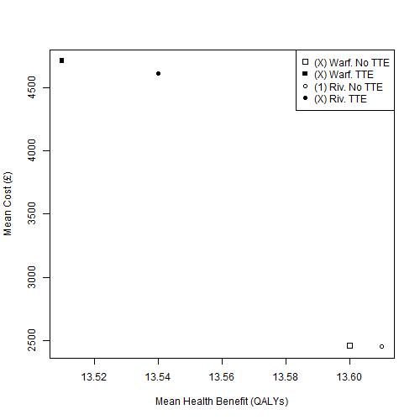

Figure 3 Cost-effectiveness plane of mean costs and mean QALYs for males aged 50 years at diagnosis. Warf: Warfarin; Riv: Rivaroxaban; TTE: Transthoracic Echocardiography

### Females, aged 50 years at diagnosis

The cost-effectiveness plane for this patient group is shown in Figure 4. As for males of the same age, of the four strategies evaluated, the No TTE strategy, using Rivaroxaban as the OAC of choice, is estimated to dominate all the other three options. However, the differences in estimated cost and QALY benefit between this option and the No TTE strategy using Warfarin as the OAC of choice are extremely small.

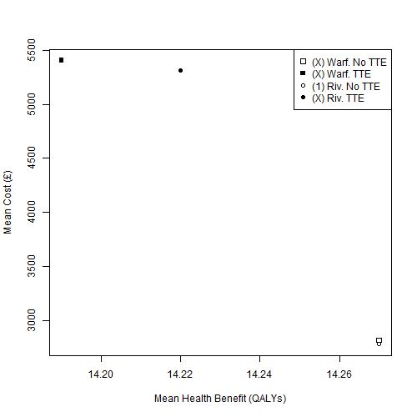

Figure 4 Cost-effectiveness plane of mean costs and mean QALYs for females aged 50 years at diagnosis. Warf: Warfarin; Riv: Rivaroxaban; TTE: Transthoracic Echocardiography

### Males, aged 65 years at diagnosis

The cost-effectiveness plane for this patient group is shown in Figure 5. Of the six strategies evaluated, the No TTE strategy using dabigatran as the OAC of choice (Dab, No TTE) is estimated to be the lowest cost option, and so forms the start of the efficiency frontier. The equivalent TTE strategy (Dab, TTE) forms the next and final part of the efficiency frontier, with an ICER, compared with Dab, No TTE, of £14 728 / QALY, as shown in Appendix E. All other options are ruled out by simple or extended dominance.

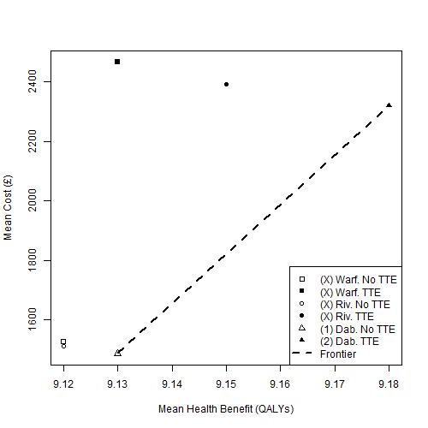

Figure 5 Cost-effectiveness plane of mean costs and mean QALYs for males aged 65 years at diagnosis. Warf: Warfarin; Riv: Rivaroxaban; Dab: Dabigatran; TTE: Transthoracic Echocardiography

### Females, aged 65 years at diagnosis

The cost-effectiveness plane for this patient group is shown in Figure 6. As for males of the same age, of the six strategies evaluated, the strategy Dab, No TTE is estimated to be the cheapest, and so forms the start of the efficiency frontier. The next and final option in the frontier is the strategy Dab, TTE, with an ICER of £12 314 / QALY, as shown in Appendix E. All other options are estimated to be ruled out by simple or extended dominance. However, the absolute differences in costs and QALYs between the Riv. No TTE and Dab. No TTE options are extremely small.

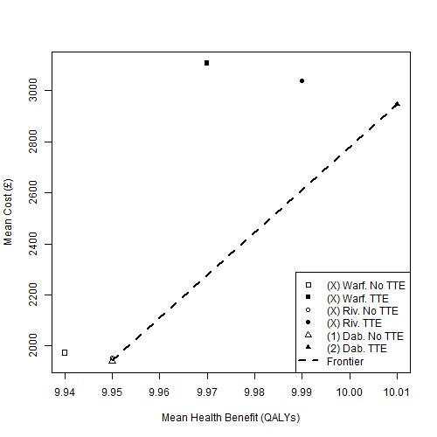

Figure 6 Cost-effectiveness plane of mean costs and mean QALYs for females aged 65 years at diagnosis. Warf: Warfarin; Riv: Rivaroxaban; Dab: Dabigatran; TTE: Transthoracic Echocardiography

## Appendix H: Additional Exploratory Analysis – the relationship between true prevalence of LAABN and mean ICER

### Introduction

This appendix illustrates how the ICER of the TTE with the No TTE strategies change, for each of the four patient groups, and each of the OACs, as a function of the estimated proportion of the patients with LA ABN, here defined as true proportion high risk (TPHR). In this sensitivity analysis, TPHR is varied between 0 and 20%.

As before, it is assumed that the OACs to be considered are warfarin and rivaroxaban for persons aged 50 years at diagnosis; and warfarin, rivaroxaban and dabigatran for person aged 65 years at diagnosis.

It is seen in all analyses (Figure 7 to Figure 10) that higher estimates of TPHR lead to lower ICERs and so greater cost-effectiveness of using TTE for the OAC decision at any given willingness to pay threshold. It is also seen that the rank order of the cost-effectiveness of each OAC is preserved; i.e. that at any TPHR, rivaroxaban has a lower ICER than warfarin in persons aged 50 at diagnosis, and dabigatran is estimated to have the lowest ICER in persons aged 65 at diagnosis.

### Persons aged 50 years at diagnosis

Figure 7 shows how the mean ICER varies for males aged 50 years at diagnosis; Figure 8 presents the equivalent estimates for females. Gender has a smaller influence on the relationship between TPHR and ICER than the OAC assumed to be prescribed if the feature were identified. Where warfarin is assumed to be the OAC of choice, using TTE in this way is not estimated to be cost-effective at a high willingness-to-pay threshold of £30,000/QALY. By contrast, the ICER of TTE is estimated to be below £30,000/QALY when rivaroxaban is assumed to be the OAC prescribed following a positive identification

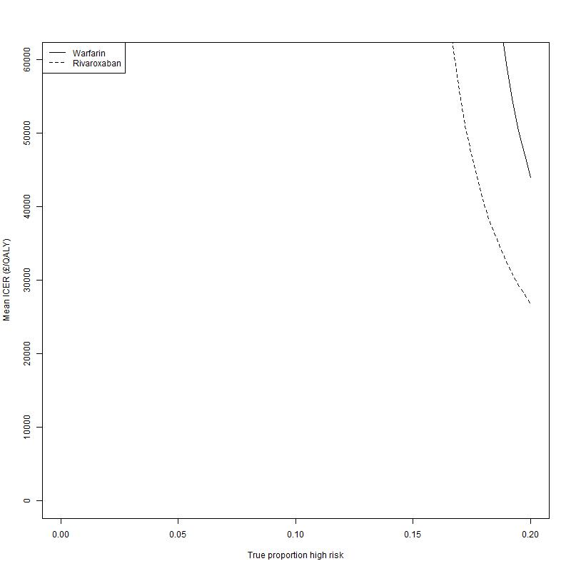

Figure 7 Relationship between mean ICER and True Proportion High Risk (TPHR) for males aged 50 years at diagnosis, if either warfarin or rivaroxaban was the OAC of choice

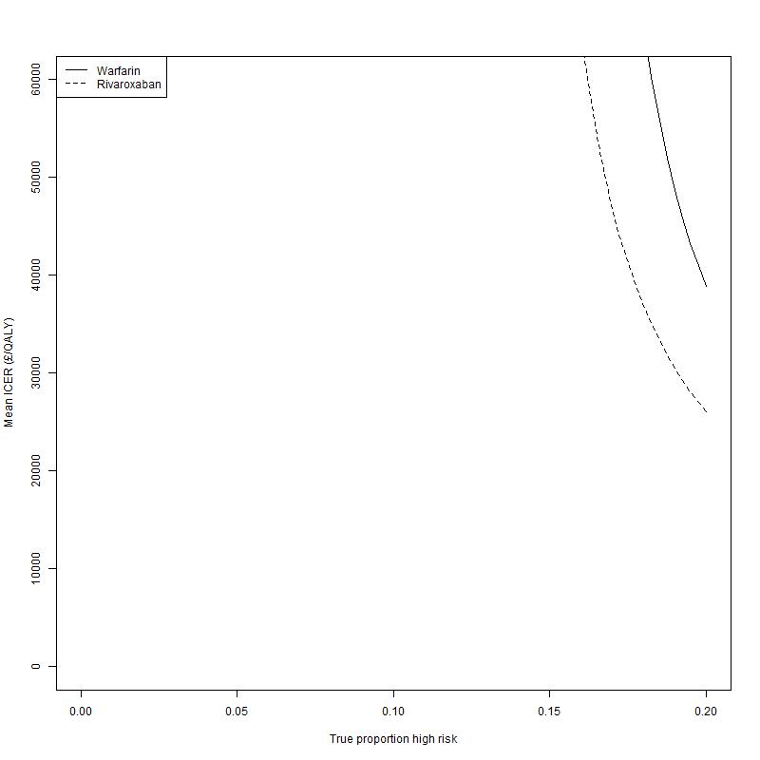

Figure 8 Relationship between mean ICER and True Proportion High Risk (TPHR) for females aged 50 years at diagnosis, if either warfarin or rivaroxaban was the OAC of choice

### Persons aged 65 years at diagnosis

Figure 9 shows how the mean ICER varies for males aged 65 years at diagnosis; Figure 10 presents the equivalent estimates for females. Dabigatran is now assumed to be an option for these patient groups, and uses of TTE involving dabigatran are estimated to have lower ICERs regardless of the TPHR level assumed. At higher TPHR estimates, the differences in ICERs in TTE strategies involving different OAC options decreases, and is substantially below £20,000/QALY regardless of OAC assumed. As with the scenarios involving persons diagnosed at the aged of 50 years, the OAC assumed appears to have much greater effect on estimated cost effectiveness than gender.

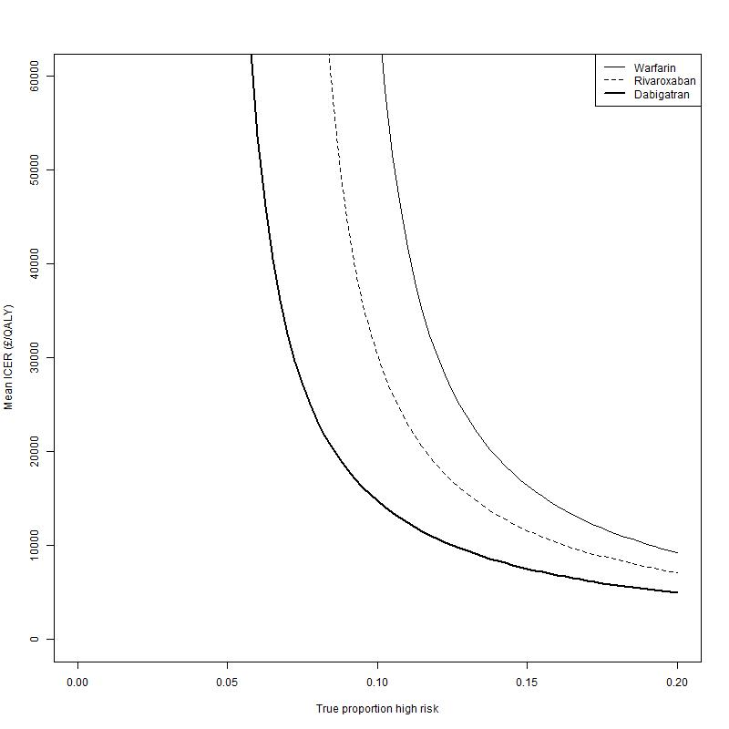

Figure 9 Relationship between mean ICER and true proportion high risk (TPHR) for males aged 50 years at diagnosis, if either warfarin, dabigatran or rivaroxaban was the OAC of choice

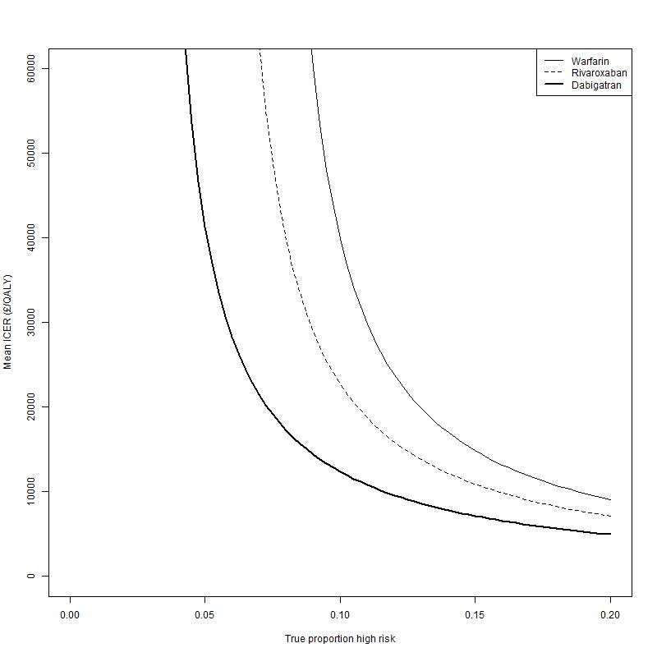

Figure 10 Relationship between mean ICER and True Proportion High Risk (TPHR) for females aged 65 years at diagnosis, if either warfarin, dabigatran or rivaroxaban was the OAC of choice

1. Precise ICER is £30,310/QALY, so the No TTE option is still optimal at £30,000/QALY. [↑](#footnote-ref-1)